Experiment 17: Docker Volumes and Port Mapping

Objective
To understand Docker data persistence using volumes and communication using port mapping, ensuring container data is not lost and services are accessible externally.

Introduction
Docker containers are ephemeral, meaning data inside a container is lost when the container is removed. Docker volumes provide persistent storage by saving data outside the container. Port mapping allows external systems (host machine or network) to access services running inside containers.

Part A: Docker Port Mapping

Step 1: Run Nginx container without port mapping
docker run -d nginx
This container runs, but cannot be accessed from the host browser.

Step 2: Run Nginx container with port mapping
docker run -d -p 8080:80 nginx
Explanation:
- -p 8080:80
  - 8080 → Host port
  - 80 → Container port

Step 3: Verify
Open browser:
http://localhost:8080
You will see the Nginx welcome page.
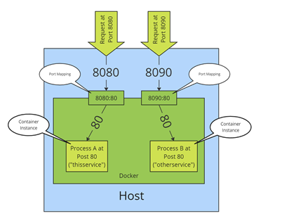

Part B: Docker Volumes (Data Persistence)

Step 1: Create a Docker Volume
docker volume create myvolume
Verify:
docker volume ls

Step 2: Run container using volume
docker run -it -v myvolume:/data ubuntu bash
Explanation:
- -v myvolume:/data
  - myvolume → Docker volume
  - /data → Container directory

Step 3: Create file inside container
Inside container:
cd /data
echo "Docker Volume Persistence Test" > test.txt
exit

Step 4: Run new container using same volume
docker run -it -v myvolume:/data ubuntu bash
Check file:
cat /data/test.txt
Output:
Docker Volume Persistence Test
This proves data persists even after container removal.

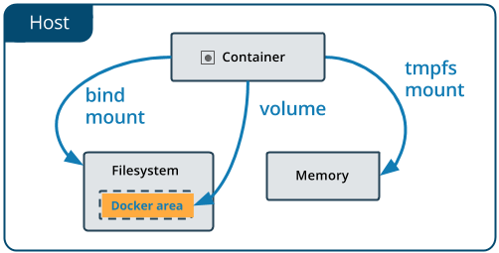

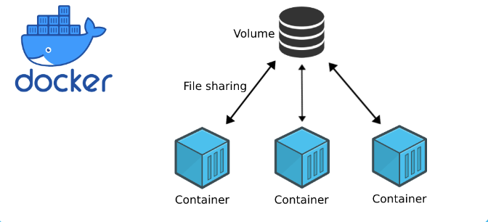

Part C: Combined Example (Port Mapping + Volume)
Run container with both volume and port mapping:
docker run -d -p 8081:80 -v myvolume:/usr/share/nginx/html nginx
Add HTML file:
docker run -it -v myvolume:/data ubuntu bash
echo "<h1>Persistent Web Page</h1>" > /data/index.html
exit
Open browser:
http://localhost:8081
Persistent webpage will appear.

Verification Commands
Check running containers:
docker ps
Check volumes:
docker volume ls
Inspect volume:
docker volume inspect myvolume

